Nuusbrief: Nasionale Veestatistiek

Van: Baldwin Netshifhefhe Direktoraat: Statistiek en Ekonomiese Analise
Tel: 012 319 8043 Faks: 012 319 8035/1 E-pos: BaldwinN@dalrrd.gov.za / SelebogoL@dalrrd.gov.za

Geagte medewerker MEI 2021

Geskatte Veegetalle in die RSA (Augustus 2020 en Februarie 2021)

Provinsie | Beeste |  | Skape |  |  |  | Varke |  | Bokke
 | Aug-20 | Feb-21 | Aug-20 |  | Feb-21 |  | Aug-20 | Feb-21 | Aug-20 | Feb-21
 | Duisende
Wes-Kaap | 466 | 466 |  | 2 545 | 2 497 | 144 |  | 141 | 202 | 199
Noord-Kaap | 419 | 418 |  | 5 182 | 5 079 | 17 |  | 16 | 448 | 446
Vrystaat | 2 054 | 2 023 |  | 4 330 | 4 362 | 109 |  | 106 | 215 | 211
Oos-Kaap | 3 050 | 3 059 |  | 6 513 | 6 394 | 81 |  | 79 | 1 991 | 1 968
KwaZulu-Natal | 2 380 | 2 320 |  | 628 | 610 | 143 |  | 143 | 662 | 651
Mpumalanga | 1 248 | 1 243 |  | 1 527 | 1 508 | 104 |  | 102 | 77 | 76
Limpopo | 860 | 850 |  | 199 | 192 | 329 |  | 329 | 902 | 909
Gauteng | 246 | 246 |  | 84 | 83 | 155 |  | 153 | 21 | 20
Noordwes | 1 576 | 1 545 |  | 596 | 585 | 275 |  | 265 | 651 | 641
Totaal | 12 298 | 12 170 |  | 21 605 | 21 310 | 1 357 |  | 1 334 | 5 170 | 5 121
Die bees-, skaap-, vark- en bokgetalle het onderskeidelik afgeneem met 01.04%, 1.37%, 1.70% en 0.95% vanaf Augustus 2020 tot Februarie 2021.
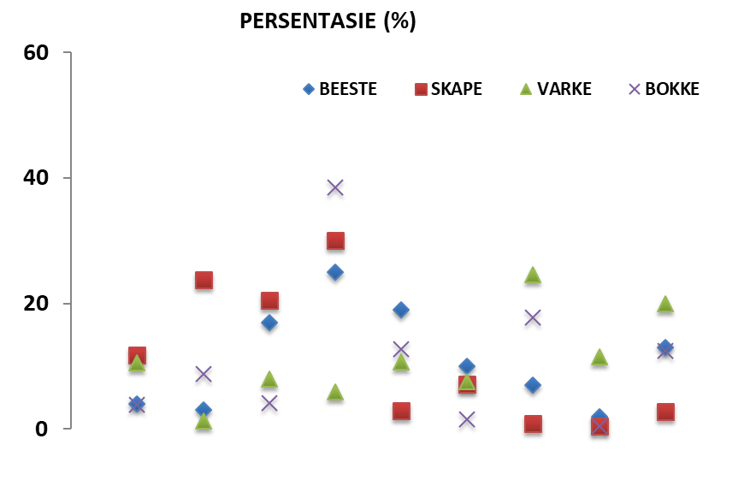
BEESTE: Die meeste beeste word in die Oos-Kaap aangetref, gevolg deur KwaZulu-Natal en dan die Vrystaat.

SKAPE: Die hoogste getal skape word in die Oos-Kaap gevind, gevolg deur die Noord-Kaap en dan die Vrystaat.

VARKE: Die meeste varke word in Limpopo aangetref, gevolg deur Noordwes en dan die Gauteng and Wes-Kaap.

BOKKE: Oos-Kaap het die meeste aantal bokke, gevolg deur onderskeidelik Limpopo en KwaZulu-Natal.

NOTAS (DEC 2020 – FEB 2021)

Reën: Byna normale reënval is gedurende hierdie tydperk aangeteken, met oorstromings en donderstorms wat sommige landbou-infrastruktuur in 'n aantal provinsies beskadig het.
Vee: Toestande het gemiddeld redelik tot goed gebly. Sterftes is aangeteken in 'n aantal provinsies: Afrika-varkpes en Bloutong in GP; Brucellose en bosluisoordraagbare siektes in KZN; donderstorms en oorstromings in NW, NC, MP, LIM en KZN.
Weiding / veld: Weens reën is die toestande redelik tot goed. Gauteng het veldbrande aangeteken, terwyl bosindringing in LIM geïdentifiseer is.
Die Departement waardeer die volgehoue ​​deelname en ondersteuning van dataverskaffers.
Maak asseblief seker dat die vraelys vir die volgende siklus voltooi is en gestuur word aan: Livestock@dalrrd.gov.za of SelebogoL@dalrrd.gov.za voor 30 Julie 2021. Alternatiewelik, stuur dit deur die koevert soos voorsien.
per pro. Direkteur: Statistiek en Ekonomiese Analise

Newsletter: National Livestock Statistics

From: Baldwin Netshifhefhe Directorate: Statistics and Economic Analysis
Tel: 012 319 8043 Fax: 012 319 8035/1 E-mail: BaldwinN@daff.gov.za / SelebogoL@daff.gov.za

Dear Co-operator MAY 2021

Estimated Livestock Numbers in the RSA (August 2020 and February 2021)

Province | Cattle |  | Sheep |  |  |  | Pigs |  | Goats
 | Aug-20 | Feb-21 | Aug-20 |  | Feb-21 |  | Aug-20 | Feb-21 | Aug-20 | Feb-21
 | Thousands
Western Cape | 466 | 466 |  | 2 545 | 2 497 | 144 |  | 141 | 202 | 199
Northern Cape | 419 | 418 |  | 5 182 | 5 079 | 17 |  | 16 | 448 | 446
Free State | 2 054 | 2 023 |  | 4 330 | 4 362 | 109 |  | 106 | 215 | 211
Eastern Cape | 3 050 | 3 059 |  | 6 513 | 6 394 | 81 |  | 79 | 1 991 | 1 968
KwaZulu-Natal | 2 380 | 2 320 |  | 628 | 610 | 143 |  | 143 | 662 | 651
Mpumalanga | 1 248 | 1 243 |  | 1 527 | 1 508 | 104 |  | 102 | 77 | 76
Limpopo | 860 | 850 |  | 199 | 192 | 329 |  | 329 | 902 | 909
Gauteng | 246 | 246 |  | 84 | 83 | 155 |  | 153 | 21 | 20
North West | 1 576 | 1 545 |  | 596 | 585 | 275 |  | 265 | 651 | 641
Total | 12 298 | 12 170 |  | 21 605 | 21 310 | 1 357 |  | 1 334 | 5 170 | 5 121
The numbers for cattle, sheep, pigs and goats decreased by approximately 1.04%, 1.37%, 1.70% and 0.95% respectively between August 2020 and February 2021.
CATTLE: Eastern Cape has the highest percentage of cattle, followed by KwaZulu-Natal and Free State.

SHEEP: The highest percentage of sheep is in Eastern Cape, followed by Northern Cape and Free State.

PIGS: Pigs are largely in Limpopo, followed by North West, Gauteng and Western Cape.

GOATS: Eastern Cape has the highest number of goats, with Limpopo and KwaZulu-Natal following respectively.

NOTES (DEC 2020 – FEB 2021)

Rain: Near to normal rainfall was recorded during this period, with flooding and thunderstorms that damaged some agricultural infrastructure in a number of provinces.
Livestock: Conditions remained reasonable to good on average. Mortalities were recorded in a number of provinces: African Swine Fever and Blue tongue in GP; Brucellosis and tick-borne diseases in KZN; thunderstorms and flooding in NW, NC, MP, LIM and KZN.
Pasture/veld: Due to rains, conditions are fair to good. GP recorded veld fires, while bush encroachment was identified in LIM.
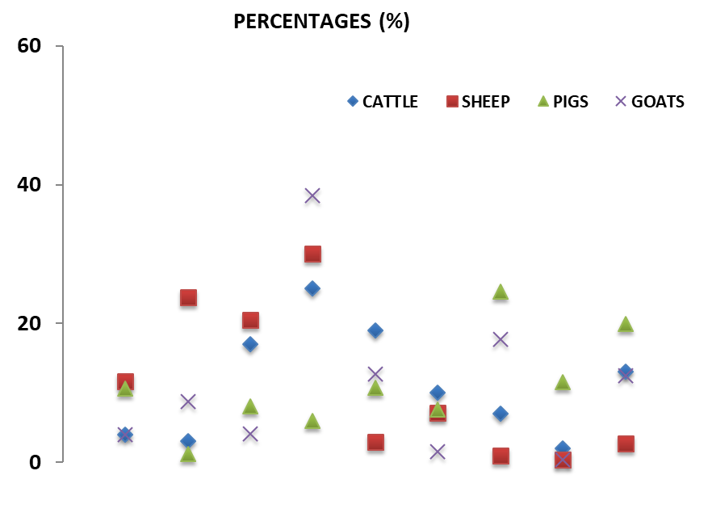
The Department appreciates the continued participation and support from data providers.
Please, ensure the questionnaire for the next cycle is completed and emailed to: Livestock@daff.gov.za or SelebogoL@dalrrd.gov.za before 30 July 2021. Alternatively, send it through the envelope as provided.
per pro. Director: Statistics and Economic Analysis

